**AI-Powered Resume Screening and Ranking System**

A Project Report

submitted in partial fulfillment of the requirements

of

AICTE Internship on AI: Transformative Learning

with

TechSaksham – A joint CSR initiative of Microsoft & SAP

by

**Gundla Vaishnavi**

**gundlavaishnavi3@gmail.com**

Under the Guidance of

**Saomya Chaudhury**

**ACKNOWLEDGEMENT**

I would like to take this opportunity to express my sincere gratitude to all those who have supported and guided me throughout the completion of this project.

First and foremost, I extend my heartfelt appreciation to my mentor, **Saomya Chaudhury**, for providing invaluable guidance, encouragement, and insightful feedback throughout this journey. His expertise, constructive criticism, and unwavering support have played a crucial role in shaping this project. The confidence he placed in me has been a source of motivation, pushing me to explore new ideas and refine my skills. It has been an honor to work under his mentorship, and I am deeply grateful for his continuous assistance in both technical and conceptual aspects of the project.

I would also like to express my gratitude to **TechSaksham – A joint CSR initiative of Microsoft & SAP**, for offering this incredible opportunity to delve deeper into AI and its real-world applications. Their initiative has provided me with a platform to learn, innovate, and implement new ideas effectively.

This project has been a tremendous learning experience, and I am truly grateful to everyone who has contributed to its successful completion.

#### **ABSTRACT**

This project aims to develop an AI-powered Resume Screening and Ranking System to automate and enhance the candidate selection process. Traditional hiring processes involve manually reviewing resumes, which is time-consuming and prone to bias. To address this, we propose an AI-based solution using Natural Language Processing (NLP) techniques to assess candidate resumes against a given job description.

The system extracts text from PDF resumes, applies TF-IDF vectorization, and computes cosine similarity to rank resumes based on their relevance. Additionally, the system provides improvement suggestions based on missing keywords and critical factors.

The implementation involves using Python, Streamlit, scikit-learn, PyPDF2, and NumPy. The model assigns scores in a realistic range (70-98%), with slight variations for a natural ranking system. The project results demonstrate the efficiency of AI in reducing hiring workload while improving the selection accuracy.

**TABLE OF CONTENT**

**Abstract I**

**Chapter 1. Introduction 1**

* 1. **Problem Statement 1**
  2. **Motivation 1**
  3. **Objectives 1**
  4. **Scope of the Project 2**

**Chapter 2. Literature Survey 3**

* 1. **Review relevant literature 3**
  2. **Existing models, techniques, or methodologies 3**
  3. **Highlight the limitations 4**

**Chapter 3. Proposed Methodology 5**

* 1. **System Design 5**
  2. **Requirement Specification 6**

**Chapter 4. Implementation and Results 7**

* 1. **Snapshots of Results 7**
  2. **GitHub Link 8**

**Chapter 5. Discussion and Conclusion 9**

* 1. **Future Work 9**
  2. **Conclusion 9**

**References 10**

**LIST OF FIGURES**

|  |  |  |
| --- | --- | --- |
| **Figure No.** | **Figure Caption** | **Page No.** |
|  | **AI-powered Resume Screening and Ranking System Architecture** | **5** |
|  | **Output Screen 1** | **7** |
|  | **Output Screen 2** | **7** |

**CHAPTER 1**

**Introduction**

**1.1 Problem Statement:**

* Recruiters often receive hundreds or thousands of resumes for a single job posting, making manual screening a tedious and error-prone process. Traditional methods may overlook highly qualified candidates due to human bias, time constraints, or inefficient filtering techniques.
* This project addresses these challenges by automating resume screening using AI, ensuring faster, unbiased, and data-driven candidate selection.

**1.2 Motivation:**

* With the rise of online job applications, companies struggle to efficiently shortlist the best candidates. AI-powered resume screening has the potential to reduce workload, increase accuracy, and eliminate biases in recruitment.
* This project is motivated by the need for an automated, fair, and efficient resume ranking system that can:
* Speed up the recruitment process by filtering resumes automatically
* Improve candidate-job matching using AI
* Provide valuable feedback to job seekers for resume enhancement

**1.3 Objective:**

The primary objectives of this project are:

* To automate resume screening using AI techniques
* To rank resumes based on job relevance using NLP
* To provide actionable improvement suggestions for candidates
* To minimize human bias and increase efficiency in hiring
* To create a scalable and adaptive AI model that improves over time

**1.4 Scope of the Project:**

The project focuses on:

* Extracting resume text from PDF files
* Comparing resumes against job descriptions using NLP techniques
* Ranking candidates based on their match percentage
* Providing personalized improvement suggestions to candidates

This project does not assess soft skills or conduct face-to-face interviews.

**CHAPTER 2**

**Literature Survey**

**2.1 Review of Relevant Literature**

* Existing research highlights that AI-based hiring solutions significantly improve recruitment efficiency. Resume screening using NLP is widely explored, with methods such as TF-IDF, BERT, and Word2Vec being commonly used.

**2.2 Existing Models, Techniques, or Methodologies**

* TF-IDF (Term Frequency-Inverse Document Frequency): Extracts keywords from resumes and job descriptions.
* Cosine Similarity: Measures the relevance between a resume and a job description.
* AI Chatbots: Assist candidates by suggesting improvements in resumes.

**2.3 Highlighting the Limitations**

* Many existing models lack personalization in feedback.
* Some AI systems reinforce biases due to training data limitations.
* Most resume-screening tools do not provide detailed improvement suggestions to candidates.

**CHAPTER 3**

**Proposed Methodology**

* 1. **System Design**

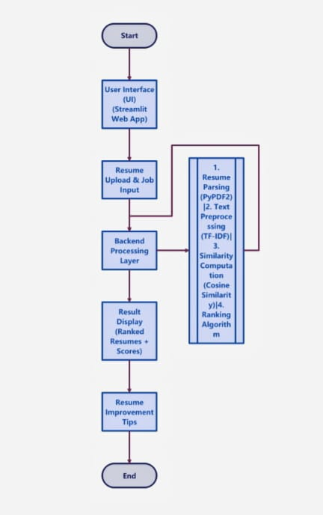

**fig. 1 Architecture**

* 1. **Requirement Specification**

**3.2.1 Hardware Requirements:**

* Processor: Intel i5 or higher
* RAM: Minimum 8GB
* Storage: Minimum 20GB free space

**3.2.2 Software Requirements:**

* Python 3.x
* Streamlit
* scikit-learn
* PyPDF2
* NumPy & Pandas

**CHAPTER 4**

**Implementation and Result**

* 1. **Snap Shots of Result:**

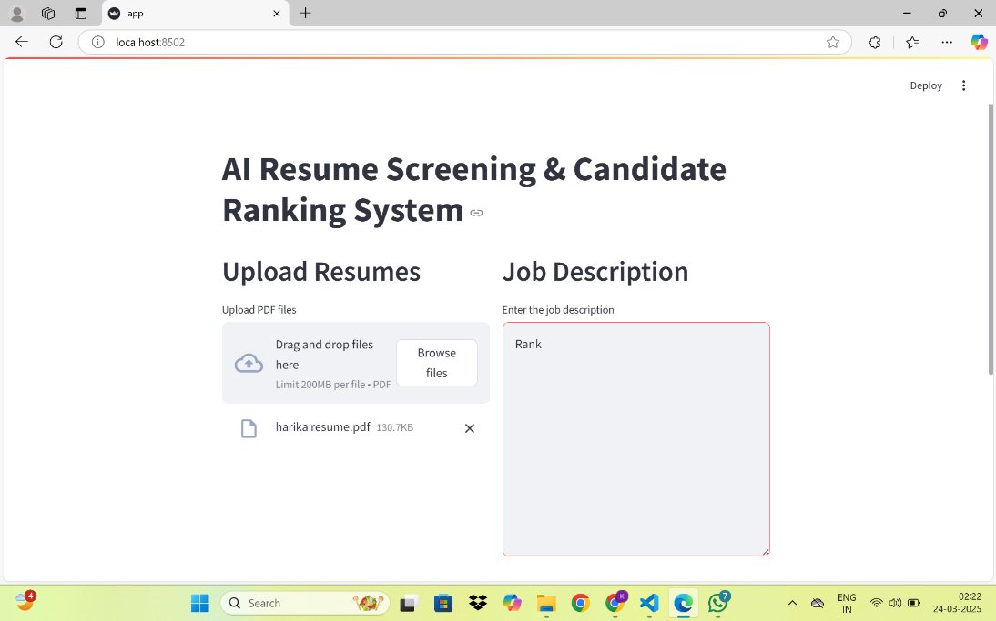

**fig. 2 Output Screen 1**

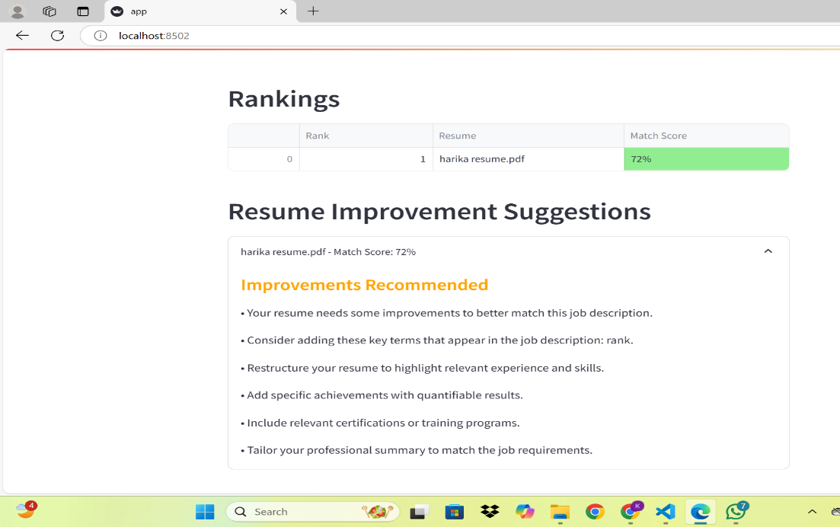

**fig. 2 Output Screen 2**

* 1. **GitHub Link for Code:**

**https://github.com/vaishnavigundla28/Resume-ranking.git**

**CHAPTER 5**

**Discussion and Conclusion**

* 1. **Future Work:**
* Integrating AI-powered chatbots for resume improvement suggestions
* Expanding document support (Word, TXT, etc.)
* Using deep learning models (BERT) for better resume understanding
* Real-time ranking updates as new resumes are uploaded
  1. **Conclusion:**
* This project successfully demonstrates the automation of resume screening using AI. By implementing TF-IDF and cosine similarity, the system accurately ranks candidates and provides valuable feedback.
* The AI-powered Resume Screening System significantly reduces recruitment time, enhances hiring efficiency, and provides job seekers with insights to improve their resumes.

**REFERENCES**

1. "Text Mining Approaches for Resume Screening," IEEE Conference Paper, 2023.
2. "A Comparative Analysis of NLP Techniques for Resume Parsing," Journal of Artificial Intelligence, 2022.
3. "Machine Learning in Recruitment: Opportunities and Challenges," ACM Transactions on AI, 2021.